ME4233 Part 2 CA 2


AY 2024/2025

A0266108E Justin Leonard
A0306098Y Wang Zeqi

Abstract
In this assignment, the main objective is to solve the lid-driven cavity problem by using explicit and implicit method. These two methods are used to check the difference in stability for explicit and implicit method.

Finite Difference Method
In order to solve the lid-driven cavity problem, the Navier-Stokes equation in the streamfunction- vorticity formulation is used.
$$\frac{∂ξ}{∂t}+\frac{∂ψ}{∂y} \frac{∂ξ}{∂x}-\frac{∂ψ}{∂x}\frac{∂ξ}{∂y}= \frac{1}{Re}+\left(\frac{∂^{2}ξ}{∂x^{2}}+\frac{∂^{2}ξ}{∂y^{2}}\right)$$
$$∇^{2}ψ= -ξ$$
For the spatial discretization, the central finite difference is used for both equations whereas the time advancement, the explicit Euler method and implicit Euler method are used. In this study, the Re is set to be 28. Additionally, the grid resolution is Nx × Ny = 50 × 20.
First of all, the Poisson equation is discretized as shown below
$$Δx=\frac{1}{Nx}=\frac{1}{50} Δy=\frac{1}{Ny}=\frac{1}{20}$$
$$Г^{2}=\frac{{(Δx)}^{2}}{{(Δy)}^{2}}$$
$$\frac{∂^{2}ξ}{∂x^{2}}+\frac{∂^{2}ξ}{∂y^{2}}= -ξ$$
$$\frac{ψ_{i+1,j }^{n}-2* ψ_{i,j }^{n}+ ψ_{i-1,j }^{n}}{Δx^{2}}+\frac{ψ_{i,j+1 }^{n}-2* ψ_{i,j }^{n}+ ψ_{i,j-1 }^{n}}{Δy^{2}}= -ξ$$
Rearranging the equation will give
$$\frac{1}{{(Δx)}^{2}} ψ_{i+1,j }^{n}+ \frac{1}{{(Δx)}^{2}} ψ_{i-1,j }^{n}+\frac{Г^{2}}{{(Δx)}^{2}} ψ_{i,j+1 }^{n}+ \frac{Г^{2}}{{(Δx)}^{2}} ψ_{i,j-1 }^{n}- \frac{2*\left(Г^{2}+1\right)}{{\left(Δx\right)}^{2}} ψ_{i,j-1 }^{n}= -ξ$$

The left-hand side term will then be used to construct the A matrix to solve the Poisson equation, while the vorticity will be the right-hand side matrix.
Au = b
Where u is the new streamfunction. This Poisson equation will then be solved using the SOR method with omega (ɷ) = 1.5. From there we will get the new streamfunction to calculate the vorticity at the next timestep.
Explicit Euler Method
For the time advancement, the initial time difference that is used dt = 0.001 and the final time $t_{f }$= 2. Therefore, the maximum timestep can be calculated as $\frac{t_{f }}{dt}=2000$.
Based on the stability condition,
$$Δt . \frac{1}{Re}\left(\frac{1}{{\left(Δx\right)}^{2}}+ \frac{1}{{\left(Δx\right)}^{2}}\right)< \frac{1}{2}$$
$$Δt . \frac{1}{Re}\left(\frac{1}{{\left(Δx\right)}^{2}}+ \frac{1}{{\left(Δx\right)}^{2}}\right)< \frac{1}{2}$$
$$Δt < 0.020656$$
Hence, the maximum delta t for the stable system is $Δt < 0.020656$. After applying the explicit Euler method and the central finite difference for the Navier-Stoke equation, it will become
$$\frac{ξ_{i,j }^{n+1}- ξ_{i,j }^{n}}{Δt}= {RHS}^{n}$$
Where the ${RHS}^{n}$,
$$-\frac{ψ_{i,j+1}^{n}- ψ_{i,j-1 }^{n} }{2 Δy}\frac{ξ_{i+1,j }^{n}- ξ_{i-1,j }^{n}}{2 Δx}+\frac{ψ_{i+1,1}^{n}- ψ_{i-1,j }^{n} }{2 Δx}\frac{ξ_{i,j+1 }^{n}- ξ_{i,j-1 }^{n}}{2 Δy}+ \frac{1}{Re} \left(\frac{ξ_{i+1,j }^{n}-2* ξ_{i,j }^{n}+ ξ_{i-1,j }^{n}}{Δx^{2}}+\frac{ξ_{i,j+1 }^{n}-2* ξ_{i,j }^{n}+ ξ_{i,j-1 }^{n}}{Δy^{2}} \right)$$
Moreover, the boundary conditions should also be calculated to determine the value of both streamfunction and vorticity at the boundary. Since u = v = 0 at the wall, and v = 0 and u = sin(2пft) at the open boundary, where f = 5. There, the boundary conditions can be calculated as follows
South Boundary
$Normal velocity v= - \frac{∂ψ}{∂x}=0$ , streamfunction $ψ$ at south boundary = 0
$$Tangential velocity u= {\frac{∂ψ}{∂y}}_{S}=0$$
$${Vorticity ξ}_{S}= - {\frac{∂^{2}ψ}{∂y^{2}}}_{S}$$

North Boundary
$Normal velocity v= - \frac{∂ψ}{∂x}=0$ , streamfunction $ψ$ at north boundary = 0
$Tangential velocity u= {\frac{∂ψ}{∂y}}_{S}= sin(2пft)$
$${Vorticity ξ}_{S}= - {\frac{∂^{2}ψ}{∂y^{2}}}_{N}$$
West Boundary
$Normal velocity u= \frac{∂ψ}{∂y}=0$ , streamfunction $ψ$ at west boundary = 0
$Tangential velocity u= {-\frac{∂ψ}{∂x}}_{W}= 0$
$${Vorticity ξ}_{S}= - {\frac{∂^{2}ψ}{∂y^{2}}}_{W}$$
East Boundary
$Normal velocity u= \frac{∂ψ}{∂y}=0$ , streamfunction $ψ$ at east boundary = 0
$Tangential velocity u= {-\frac{∂ψ}{∂x}}_{E}= 0$
$${Vorticity ξ}_{S}= - {\frac{∂^{2}ψ}{∂y^{2}}}_{S}$$
After putting all the necessary parameters and boundary conditions, the energy array can be seen as below.

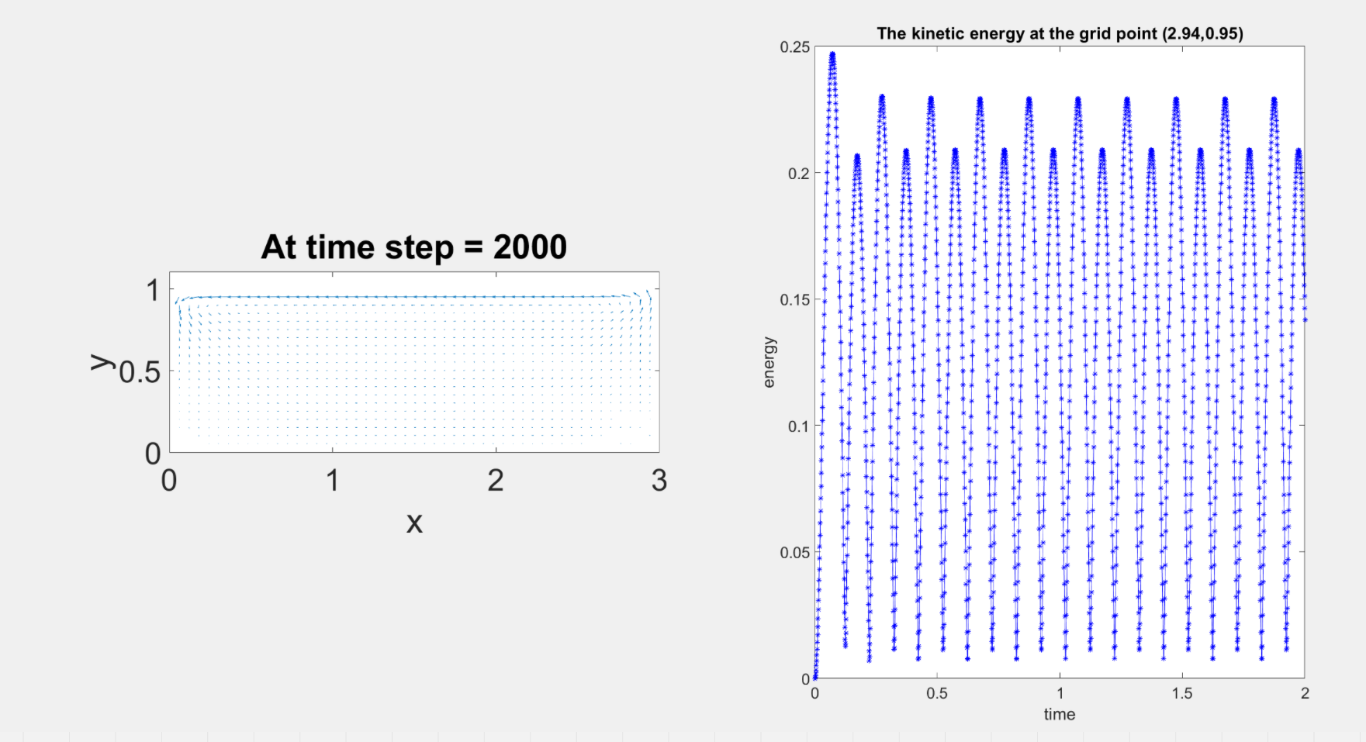
Figure 1. The energy density and vector field for explicit method (dt = 0.001)
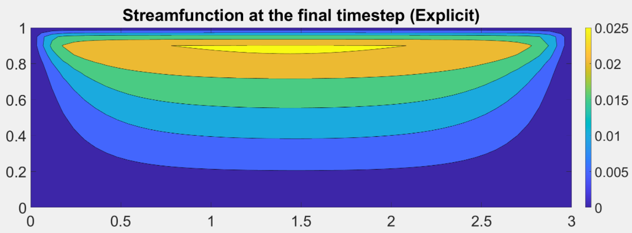
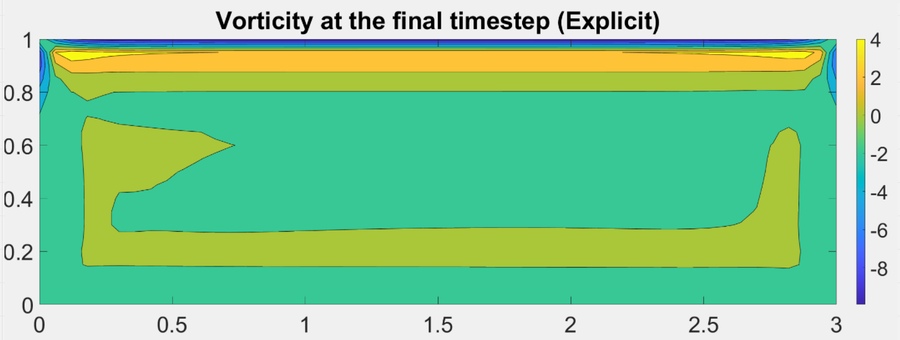
Figure 2. Streamfunction and vorticity plot at the final timestep (dt = 0.001)
Unfortunately, when we put $Δt$ to be bigger than $0.020656$, the instability starts to occur. It can be observed from the energy array below where in the early timestep, there are significant fluctuations. Additionally, the iteration also stopped before reaching the maximum time step. This shows that the system becomes unstable when the $Δt$ is set to be bigger than $Δt$ value set by the stability criterion.
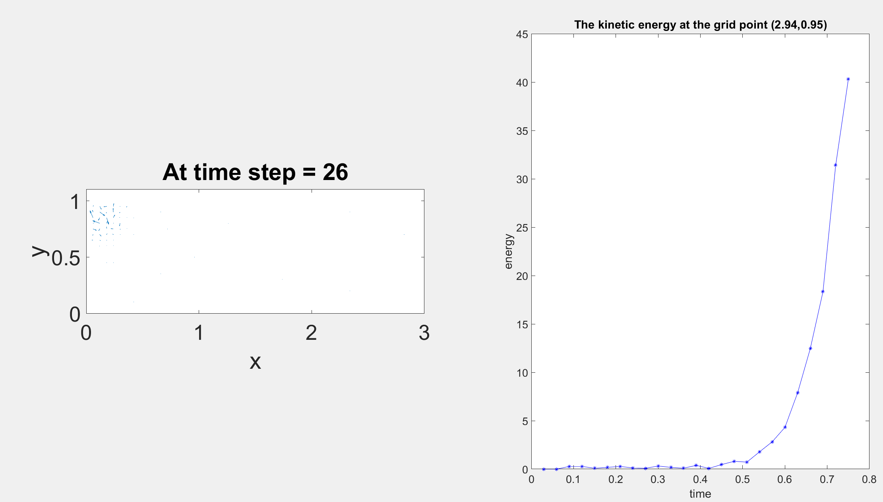
Figure 4. The unstable energy density and vector field for explicit method (dt = 0.03)
Implicit Euler Method
For the implicit Euler Method, there is a slight difference on the Navier-Stoke equation where it becomes,
$$\frac{ξ_{i,j }^{n+1}- ξ_{i,j }^{n}}{Δt}= {RHS}^{n+1}$$
Where the ${RHS}^{n+1}$,
$$-\frac{ψ_{i,j+1}^{n}- ψ_{i,j-1 }^{n} }{2 Δy}\frac{ξ_{i+1,j }^{n+1}- ξ_{i-1,j }^{n+1}}{2 Δx}+\frac{ψ_{i+1,1}^{n}- ψ_{i-1,j }^{n} }{2 Δx}\frac{ξ_{i,j+1 }^{n+1}- ξ_{i,j-1 }^{n+1}}{2 Δy}+ \frac{1}{Re} \left(\frac{ξ_{i+1,j }^{n+1}-2* ξ_{i,j }^{n+1}+ ξ_{i-1,j }^{n+1}}{Δx^{2}}+\frac{ξ_{i,j+1 }^{n+1}-2* ξ_{i,j }^{n+1}+ ξ_{i,j-1 }^{n+1}}{Δy^{2}} \right)$$
Rearranging the right-hand side will give
$$\frac{1}{{\left(Δx\right)}^{2}} \left(\left(\frac{{-Г(ψ}_{i,j+1}^{n}- ψ_{i,j-1 }^{n}){ (ξ}_{i+1,j }^{n+1}- ξ_{i-1,j }^{n+1}) }{4}+\frac{{Г(ψ}_{i+1,1}^{n}- ψ_{i-1,j }^{n}) (ξ_{i,j+1 }^{n+1}- ξ_{i,j-1 }^{n+1}) }{4}\right)+ \frac{1}{Re} \left(ξ_{i+1,j }^{n+1}-2* ξ_{i,j }^{n+1}+ ξ_{i-1,j }^{n+1} +Г^{2} (ξ_{i,j+1 }^{n+1}-2* ξ_{i,j }^{n+1}+ ξ_{i,j-1 }^{n+1}) \right)\right)$$
Then multiply the entire equation with 4 will give
$${4Cξ}_{i,j }^{n+1}-4C ξ_{i,j }^{n}= {RHS}^{n+1}$$
Where the ${RHS}^{n+1}$
$${-(Гψ}_{i,j+1}^{n}- Гψ_{i,j-1 }^{n}-\frac{4}{Re} ) ξ_{i+1,j }^{n+1}+({Гψ}_{i,j+1}^{n}- {Гψ}_{i,j-1}^{n}+\frac{4}{Re}){ ξ}_{i-1,j }^{n+1}+({Гψ}_{i+1,1}^{n}- {Гψ}_{i-1,1}^{n}+ \frac{4Г^{2}}{Re} ) ξ_{i,j+1 }^{n+1}-({Гψ}_{i+1,1}^{n}- {Г(ψ}_{i-1,1}^{n}-\frac{4Г^{2}}{Re}) ξ_{i,j-1 }^{n+1}- \frac{8 (Г^{2}+1)}{Re}ξ_{i,j }^{n+1}$$
Subsequently, vorticity with timestep n+1 will be moved to the LHS and vorticity with timestep n will be moved to the RHS.
$$\left(4C+ \frac{8}{Re } \left(1+ Г^{2}\right)\right)ξ_{i,j }^{n+1} + {(Гψ}_{i,j+1}^{n}- Гψ_{i,j-1 }^{n}-\frac{4}{Re} ) ξ_{i+1,j }^{n+1}- ({Гψ}_{i,j+1}^{n}- {Гψ}_{i,j-1}^{n}+\frac{4}{Re}){ ξ}_{i-1,j }^{n+1 }- ({Гψ}_{i+1,1}^{n}- {Гψ}_{i-1,1}^{n}+ \frac{4Г^{2}}{Re} ) ξ_{i,j+1 }^{n+1}+ ({Гψ}_{i+1,1}^{n}- {Г(ψ}_{i-1,1}^{n}-\frac{4Г^{2}}{Re}) ξ_{i,j-1 }^{n+1}= 4C ξ_{i,j }^{n}$$
This requires us to create another Au = b equation, where the A matrix will be the coefficient of the left-hand side vorticity, the u vector is the vorticity at timestep n+1, and the b vector is the vorticity at timestep n. When using the implicit method for dt = 0.03, which is bigger that the dt given by the stability criterion, the energy array is shown below.
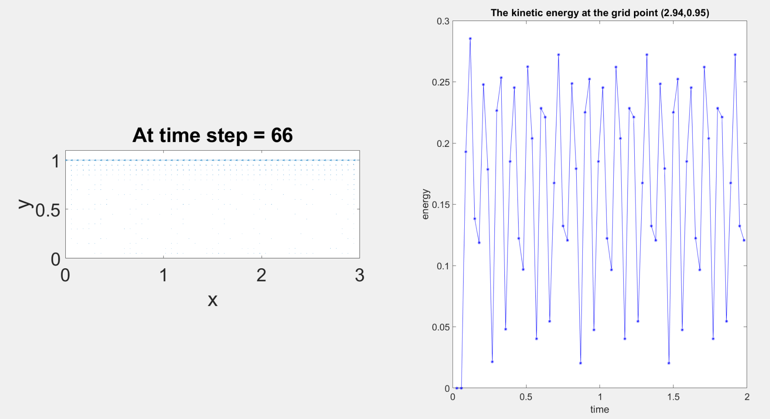
Figure 5. The energy array and vector field for implicit method (dt = 0.03)
Additionally, the iteration also manages to reach the maximum timestep, which is 66 for dt = 0.03 (2/0.03).
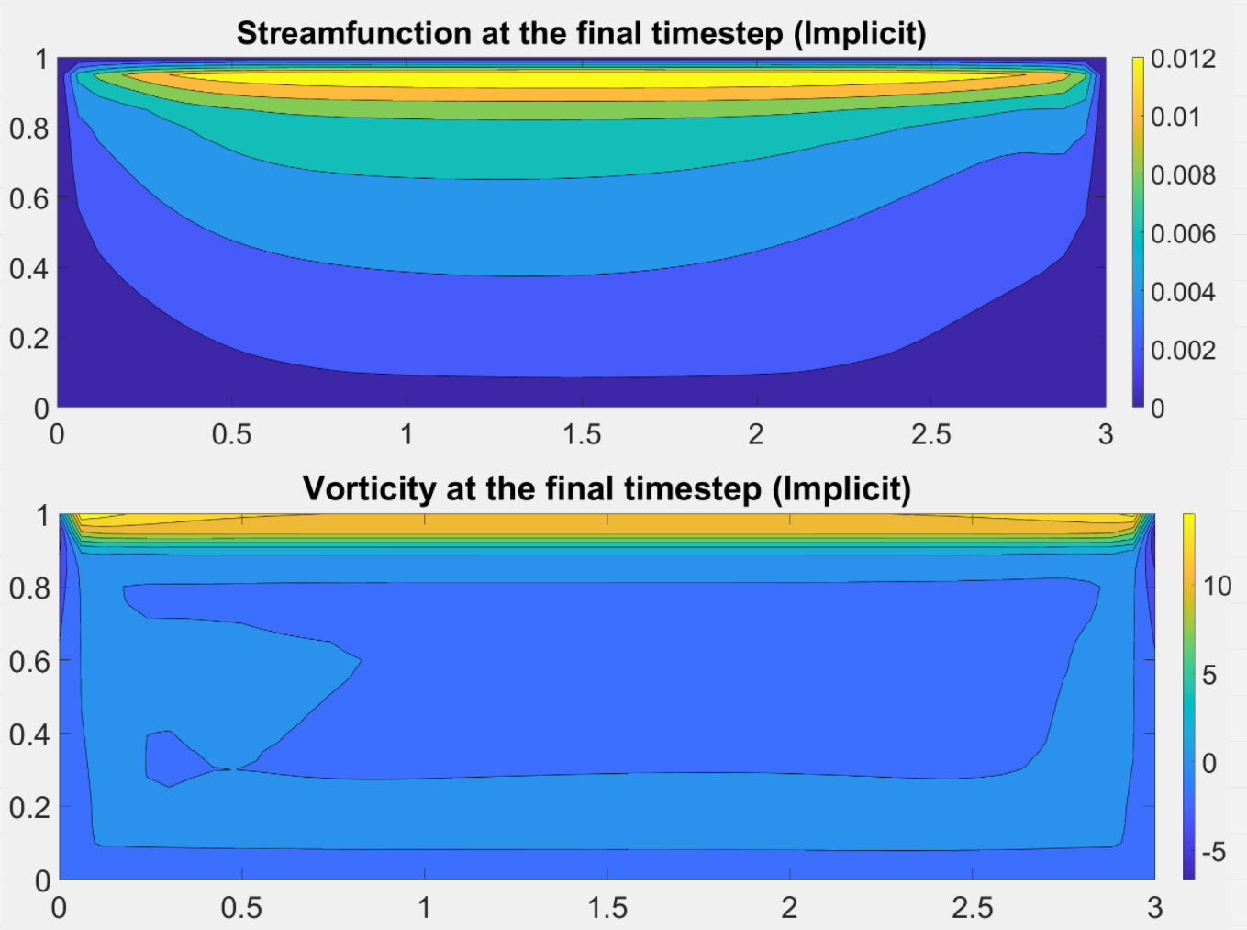
Figure 6. Streamfunction and vorticity plot at the final timestep (dt = 0.03)
Task c FFT
The FFT is often used in numerical simulations to analyse the spectrum of a signal to understand its frequency characteristics. For physical phenomena with periodic or oscillatory characteristics, the FFT can help to study their main frequency components and harmonic structures. In fluid mechanics and mechanical engineering, FFT can be used to analyse signals such as velocity, pressure, etc. that vary with time, and extract frequency information for further physical analysis or model calibration.

The output of the FFT contains amplitude and phase information for each frequency:
- Amplitude: indicates the strength of this frequency component. In a spectrogram, the dominant frequency usually corresponds to the largest amplitude, while other smaller peaks may correspond to harmonics or noise.
- Frequency: The frequency with the largest amplitude corresponds to the dominant frequency of the signal, which reflects the periodicity of the signal.

Numerical Implementation
Time series analysis at point C (1.5,0.5)
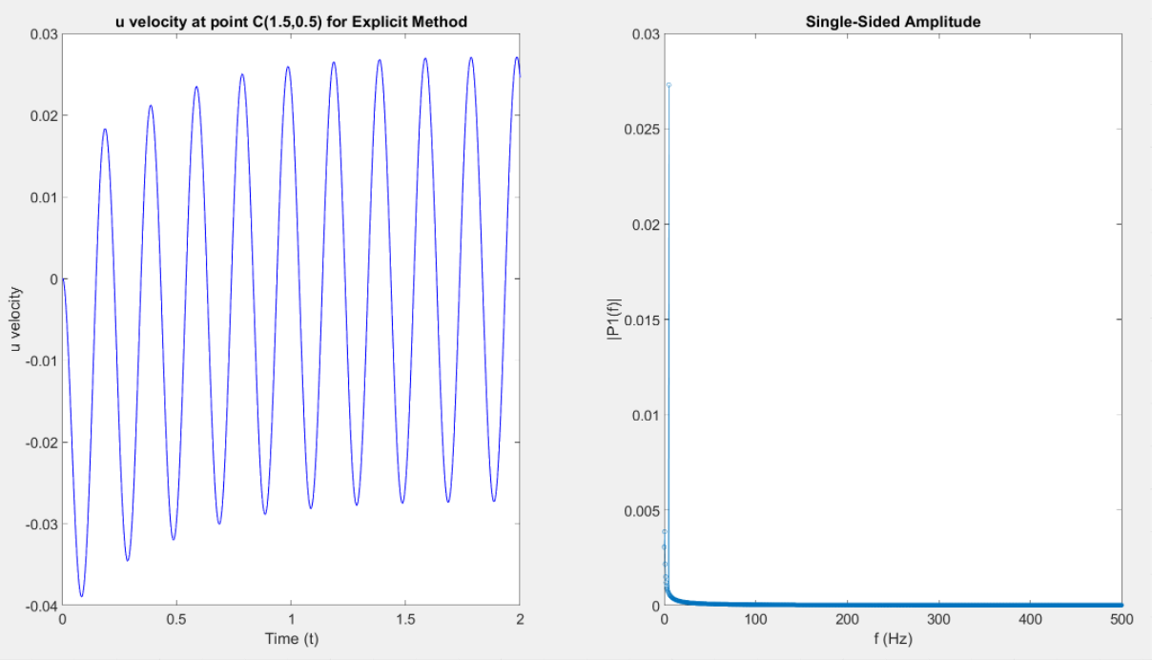
Figure 7. The frequency plot for explicit method (dt = 0.001)
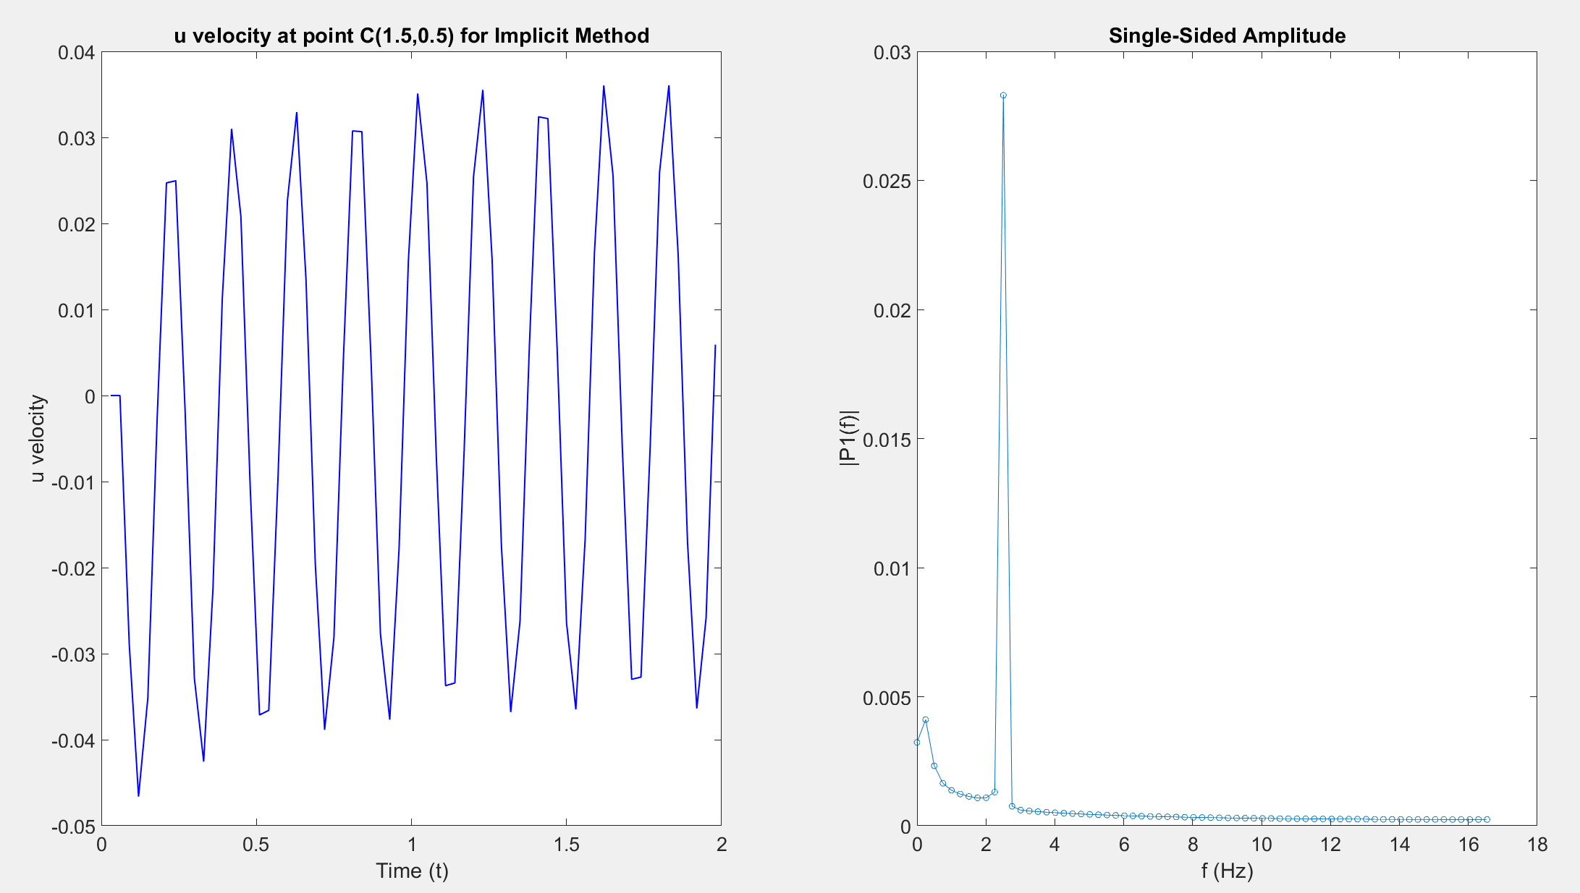
Figure 8. The frequency plot for implicit method (dt = 0.03)
- Left Plot (u-velocity)
- Steady periodic oscillation after t≈1 between 0.03 and -0.03, means a recurring flow fluctuation around Point C.
- Both plots show that there are 10 waves in the span of 2 seconds. Hence, the frequency at point C is indeed 5.

- Right Plot (FFT)
- The curve shows the significant frequency component is concentrated in the lower frequency range.
- There is noticeable peak near 5Hz on this plot, which show the dominant frequency.
Conclusion
- Explicit method is easier to be implemented. However, it is limited by the stability criterion where the value of $Δt$ cannot be set to be huge. Alternatively, implicit method can be used to achieve a stability while using a higher $Δt$
- This periodic fluctuations at low frequencies indicate the changes of northern boundary conditions.
- The right plot shows a clearer spectrum with no high frequencies interference components indicating the velocity fluctuations at this point are stable and no significant noise interference about this system.
This analysis confirms that our numerical simulation accurately captures the periodic flow behaviour and reveals the dominant frequency matches the driving force.

